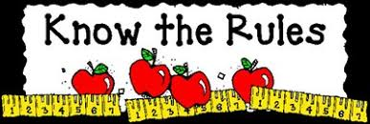

5th Grade Rules and Consequences

**Traditional Classroom Rules**

* Follow directions/Do your best at all times
* Respect yourself and others
* Listen when others are talking
* Work quietly and don’t disturb
* Enter class focused and prepared to learn

**Virtual Classroom Rules (Zoom, Google Classroom, etc)**

* Show up a few minutes early, wait to be admitted into class
* Find a quiet place to work
* Be respectful at all times
* Stay muted while in session. Raise your hand if you have something to say. Then unmute yourself once given permission to speak. Then mute yourself once more.
* Stay focused on the lesson and your assignment or task, so that you don’t miss any information.

**Consequences**

1st offense – Verbal Warning

2nd offense – Student/Teacher Conference

3rd offense – Parent Contact

4th offense – Parent/Teacher/Student Conference

5th offense – Office Referral